Notes

Block elements always start from new lines like p and div

Inline elements are inserted in same line like b abbr etc

Span is used for styling text inbetween elements

Display inline block can also show divs side by side

Class can be used multiple times

Class is also case sensitive

There can only be 1 id for 1 element only, single id cannot be assigned to multiple elements.

Id is defined as #idname

Ids can be used as bookmarks

An HTML iframe is used to display a web page within a web page.

83 out of 106 done html javascripts or scripts



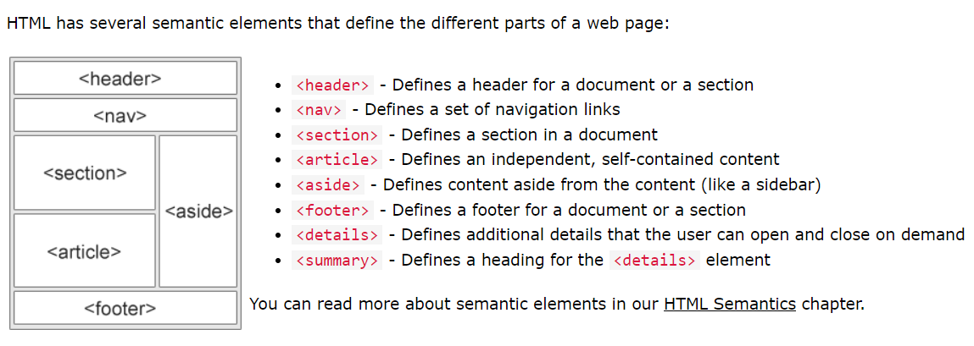

Fixed position always stays on the screen

Sticky moves when scrolled